Task 1:

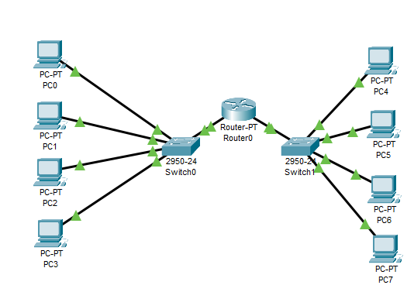

Task 2:

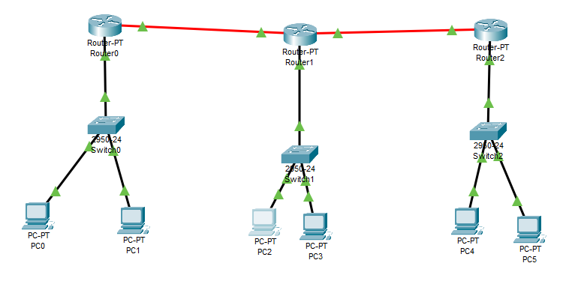

Bus topology:

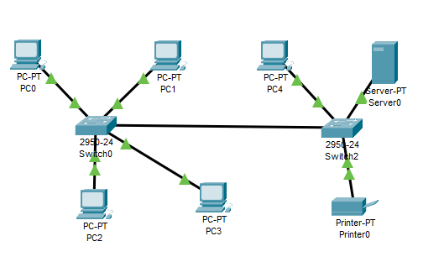

The main cable known as the bus connects all of the workstations. Bus topologies are best suited in small, temporary networks. One advantage of a bus topology is that it is easy to connect new devices to it. Another advantage is that it is cheaper than other topologies because it doesn’t need a server or hub. A disadvantage of this topology is that it isn’t suitable for large networks. To add to this adding more devices will slow down the network.

Star topology:

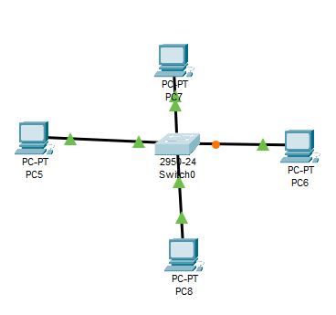

All computers are indirectly connected to each other through the server/central computer Every computer is directly connected to this server/central computer. A star topology is best suited for networks that need a cental hub like a school network. One advantage of a star topology is that if one of the computers are damaged the rest of then network is unaffected. A disadvantage of a star topology is that it is expensive because it needs a server/hub and lots of wiring. Another disadvantage is that if the server goes down then the whole network goes down.221

Ring topology:

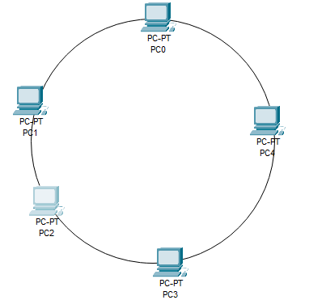

All the computers are connected in a loop in a ring topology. Adjacent pairs are directly connected. A ring topology is best suited for a simple network like a small office. One advantage of a ring topology is that it is adaptable so more workstations can be added easily. A disadvantage is that since data passes through all of the computers their isn’t any privacy.

Mesh topology:

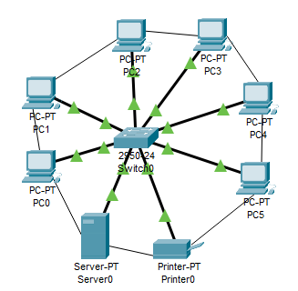

A mesh topology is a network set up where each device is interconnected with two or more other devices. The mesh topology was originally developed for military applications but now it is best suited for home automation. One advantage of a mesh topology is that it is more efficient than other topologies. Mesh topologies also have a high level of security that maintains privacy. A disadvantage is that it is an expensive topology to install. To add to this mesh topologies are very complex and tedious to set up.